**Mental health signposting resources**

General, crisis and counselling

* Hubofhope.co.uk – location-based database of support services
* Mind
* Samaritans.org 116 123
* www.Rethink.org
* www.sane.org.uk – supports friends and family also
* Childline.org.uk 0800 1111
* Young Minds (text line: YM to 85258 and parentline 0808 802 5544)
* Stepfinder app: confidential database & directions to local help & advice
* Mood Panda: track your mood and get anonymous support
* MindEd online training
* Text SHOUT to 85258 – free confidential text support
* Catch it – manage negative thoughts & look at problems differently

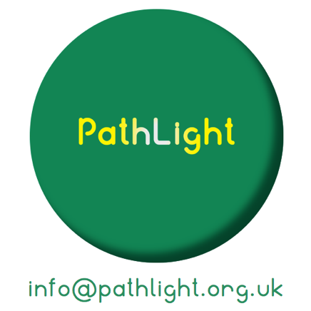

Eating disorders

* B-eat.co.uk

Stress, anxiety and depression

* NHS Stress & Anxiety Companion app: breathing, music, games, CBT style.
* Thrive: games to track mood; learn methods to control stress & anxiety
* Clear Fear app – teenage anxiety management and support network
* Youper app: quick chats, personalised meditations, mood tracker
* SAM app
* NoPanic.org.uk anxiety reduction website & phoneline 0844 967 4848
* Companion - anxiety reduction app
* The Blurt Foundation: blurtitout.org – depression support
* Charlie Waller Memorial Trust: xwmt.org.uk – depression support
* Oldham: Healthy Minds

Self harm

* Blue Ice: helps young people manage emotions
* Calm Harm app

Psychosis and schizophrenia

* Hearing Voices

Suicide

* Stay Alive: suicide prevention app
* Papyrus-uk.org 0800 068 4141
* CALM – thecalmzone.net 0800 58 58 58
* ZeroSuicideAlliance.com
* Oldham Safe Haven (referred via A&E)

Wellbeing and mindfulness

* Headspace
* My Possible Self
* Insight Timer
* iMood Journal
* Feeling good: positive mindset
* Sleepio
* www.tarabrach.com/beginner-med-kit